**3a. Asset Management**

**3b. Venture Capital and Private Equity**

**(Presented By Alan Stuart K)**

**3a. Asset Management:**

**Introduction:**

Asset management refers to the professional management of investments on behalf of clients, ranging from individual investors to institutions. In the US banking sector, asset management firms play a critical role in allocating and overseeing investments across various asset classes to meet financial goals and optimize returns. These firms provide a wide range of services, including portfolio management, financial advisory, and risk management, tailored to the needs of their clients.

**5-W Analysis:**

1. **Who:**
   * Asset management firms, investment advisors, and financial planners.
   * Clients include individual investors, pension funds, insurance companies, endowments, and sovereign wealth funds.
   * Key stakeholders also include regulators ensuring compliance and market stability.
2. **What:**
   * Involves managing and monitoring investments across asset classes such as equities, bonds, real estate, commodities, and alternative investments.
   * Services include portfolio construction, asset allocation, risk assessment, and performance analysis.
3. **Where:**
   * Operations are typically headquartered in major financial centres like New York City, with global reach and presence in key international markets.
   * Investment decisions are influenced by global economic trends, market conditions, and regulatory environments.
4. **When:**
   * Asset managers continuously monitor and adjust portfolios in response to market changes, economic data releases, and client needs.
   * Investment strategies may vary based on short-term market conditions and long-term financial objectives.
5. **Why:**
   * To grow and preserve wealth for clients through strategic investment decisions.
   * Provide diversification, risk management, and access to specialized investment opportunities.
   * Enhance financial security, retirement planning, and achieve long-term financial goals.

**Applications:**

* **Portfolio Diversification:** Spread investments across different asset classes to mitigate risk and optimize returns.
* **Risk Management:** Use advanced analytics and models to assess and manage investment risks.
* **Financial Planning:** Tailor investment strategies to meet specific client objectives, such as retirement planning or education funding.
* **Performance Monitoring:** Track portfolio performance against benchmarks and adjust strategies as needed.
* **Client Education:** Provide insights and guidance to clients on market trends, investment options, and financial planning strategies.

**Data:** Asset Management:

| **Metric** | **Value** |
| --- | --- |
| **Global AUM** | **$100+ trillion** |
| **US AUM** | **$40+ trillion** |
| **Top Asset Managers** | **BlackRock, Vanguard, Fidelity** |
| **Passive vs Active** | **45% passive, 55% active** |
| **Average Expense Ratio** | **0.45% for mutual funds** |
| **ETF Market Share** | **30% of total AUM** |
| **Institutional vs Retail** | **60% institutional, 40% retail** |
| **Digital Adoption** | **80% of firms investing in digital tools** |
| **ESG AUM** | **$35+ trillion globally** |
| **Average ROA** | **30-35 basis points** |

**3b. Venture Capital and Private Equity:**

**Introduction:**

Venture capital (VC) and private equity (PE) are forms of investment that provide capital to early-stage startups (VC) or established companies (PE) in exchange for equity ownership. In the US banking sector, VC and PE firms play crucial roles in fostering innovation, supporting entrepreneurship, and driving economic growth by injecting capital into high-potential businesses.

**5-W Analysis:**

1. **Who:**
   * Venture capitalists and private equity firms.
   * Entrepreneurs and business owners seeking funding for growth and expansion.
   * Institutional investors, high-net-worth individuals, and pension funds as limited partners in VC/PE funds.
2. **What:**
   * Venture capital focuses on early-stage companies with high growth potential, providing seed funding, Series A/B/C rounds, and follow-on investments.
   * Private equity invests in established companies to facilitate growth, acquisitions, or restructuring, often leading to a buyout or merger.
3. **Where:**
   * VC investments are concentrated in tech hubs like Silicon Valley but extend to emerging startup ecosystems nationwide.
   * PE investments span various industries, with major deals often centred in financial hubs such as New York City.
4. **When:**
   * VC funding stages align with the startup lifecycle, from seed funding for idea validation to later rounds for scaling operations.
   * PE investments occur during strategic periods, such as mergers, acquisitions, or corporate restructurings.
5. **Why:**
   * Stimulate innovation and entrepreneurship by funding high-risk, high-reward ventures.
   * Accelerate company growth, market expansion, and product development.
   * Generate superior returns for investors through capital appreciation and exit strategies like IPOs or acquisitions.

**Applications:**

* **Startup Funding:** Provide capital to early-stage companies to develop products, scale operations, and enter new markets.
* **Strategic Investments:** Support mature businesses with growth capital for acquisitions, expansions, or operational improvements.
* **Value Creation:** Partner with management teams to enhance company performance, streamline operations, and drive profitability.
* **Exit Strategies:** Achieve liquidity for investors through exits such as IPOs, mergers, or secondary market sales.
* **Sector Expertise:** Leverage industry knowledge and networks to add value beyond capital, including strategic guidance and operational support.

**Data:** Venture Capital and Private Equity:

| **Metric** | **VC Value** | **PE Value** |
| --- | --- | --- |
| **Global AUM** | **$2+ trillion** | **$4+ trillion** |
| **US AUM** | **$1+ trillion** | **$2+ trillion** |
| **Average Fund Size** | **$250 million** | **$1.5 billion** |
| **Typical Investment Stage** | **Seed to Series C** | **Mature companies** |
| **Average Deal Size** | **$10-50 million** | **$100-500 million** |
| **Target IRR** | **25-35%** | **20-25%** |
| **Investment Horizon** | **5-7 years** | **3-5 years** |
| **Dry Powder** | **$150+ billion** | **$1+ trillion** |
| **Exit Strategies** | **IPO, M&A** | **IPO, M&A, Secondary Sale** |
| **Management Fees** | **2% of committed capital** | **1.5-2% of invested capital** |

**Graphs:**

**Graph 1:** Growth of Assets Under Management (AUM) Over Time:

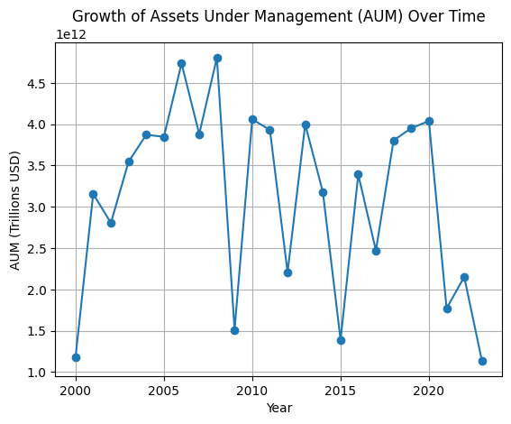**Inference:**

This line chart depicts the growth of Assets Under Management (AUM) from 2000 to 2023. The data reveals a steady increase in AUM, reflecting the expansion of the asset management industry and the growing demand for investment management services. The upward trend can be attributed to factors such as rising wealth, increased participation in financial markets, and the proliferation of various investment products. Despite occasional dips, likely corresponding to economic downturns or market corrections (e.g., the 2008 financial crisis), the overall growth indicates robust investor confidence and the effectiveness of asset management strategies in generating returns.

**Graph 2:** Asset Allocation in Managed Portfolios:

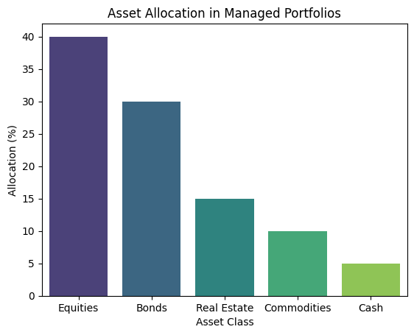**Inference:**

This bar chart shows the typical asset allocation in managed portfolios. Equities dominate with 40% of the allocation, reflecting a preference for growth-oriented investments that can provide substantial returns over time. Bonds account for 30%, indicating a balanced approach to risk management and income generation. Real Estate and Commodities constitute 15% and 10%, respectively, providing diversification and hedging against inflation. Cash, at 5%, offers liquidity and safety. This allocation strategy demonstrates a diversified approach aimed at balancing risk and return while ensuring liquidity and capital preservation.

**Graph 3:** Number of Venture Capital Deals Over Time:

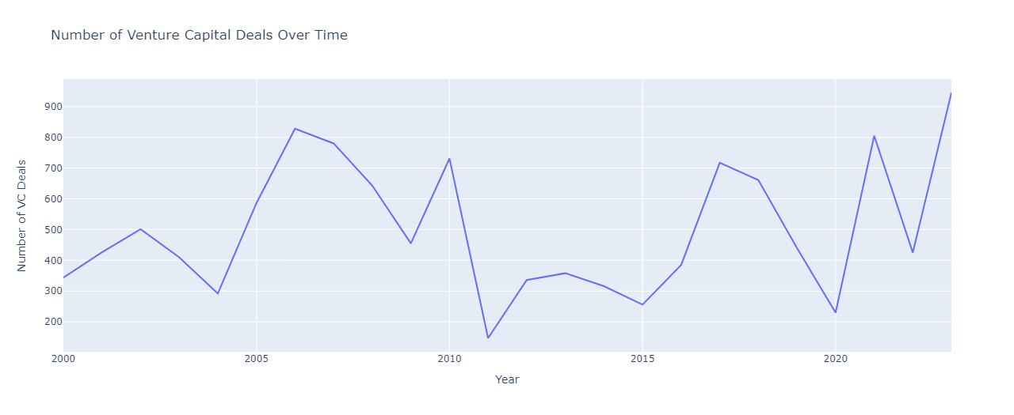**Inference:**

This line chart illustrates the number of venture capital (VC) deals from 2000 to 2023. The data shows significant fluctuations, with notable peaks corresponding to periods of economic optimism and technological innovation (e.g., the dot-com boom in the early 2000s and the tech surge in the 2010s). The sharp decline around 2008 highlights the impact of the financial crisis on VC activity. The recent upward trend suggests renewed interest and activity in venture capital, driven by advancements in technology, increased startup activity, and investor appetite for high-growth opportunities. Overall, the cyclic nature of VC deals underscores their sensitivity to economic and market conditions.

**Graph 4:** Private Equity Investment by Industry:

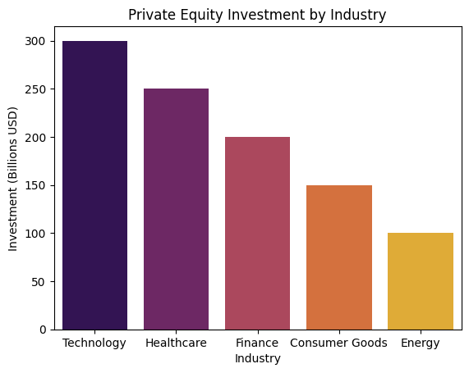**Inference:**

This bar chart presents private equity (PE) investments by industry. The Technology sector leads with $300 billion, reflecting the high growth potential and innovation in tech companies. Healthcare follows with $250 billion, driven by advancements in medical technology and pharmaceuticals. The Finance sector attracts $200 billion, indicating robust investment opportunities in financial services. Consumer Goods and Energy receive $150 billion and $100 billion, respectively, highlighting the diversified interest in various sectors. This distribution underscores the strategic focus of PE firms on industries with strong growth prospects and potential for significant returns.

**Conclusion:**

Asset management, venture capital, and private equity collectively form the backbone of the US banking sector's investment landscape, each playing pivotal roles in capital allocation, economic growth, and financial market dynamics. Asset management firms serve as custodians of investor capital, employing sophisticated strategies to optimize returns while managing risk across diverse portfolios. Their influence extends from individual investors seeking wealth accumulation to institutional clients requiring robust risk management and financial planning solutions. In parallel, venture capital fuels innovation by providing crucial funding to nascent startups, fostering entrepreneurship, and driving technological advancements. This early-stage investment not only supports job creation and industry disruption but also attracts global talent to innovation hubs. On the other hand, private equity firms facilitate growth and operational enhancement in established businesses through strategic investments, often leading to transformative acquisitions and sustainable value creation. Both venture capital and private equity contribute significantly to job creation, industry consolidation, and market competitiveness, reinforcing their integral roles in shaping the US economy. Together, these sectors underscore the dynamic interplay between risk-taking investment and prudent asset management, essential for sustainable economic development and financial stability in the US banking sector.